Priboj: An online town
1
1
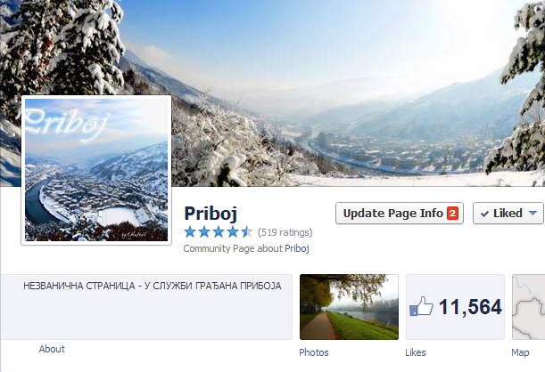

It wouldn’t be strange for a small town in the corner of mountainous Serbia to have active online community and the Facebook page with over 11,000 likes, unless one considers the fact that the town is failing industrial center with only around 15,000 residents in the urban area of municipality. This case study addresses the influence of the unofficial Facebook page “Priboj” on the communication, mobilization and the accountability of the local government in town of Priboj.

- Decline of Priboj

Priboj, a small multiethnic town in South-Western Serbia, in 1991 had 35,951 inhabitants who were mainly employed in a several industrial enterprises. In the next two decades most of the factories downsized production or closed due to failed privatizations. FAP, the local motor vehicle factory and a symbol of the town’s progress, ended up on the edge of survival with less than thousand workers, obsolete production and occasional financial injections from the government. Decline of FAP which once used to employ seven thousand people, meant decline of Priboj. Soon, people started leaving the town and the population of Priboj declined to 27,133 in 2011, out of which only 14,920 living in the urban area of municipality. With the aging population, migrations and inability of local government to make any significant change, citizens became lethargic and uninterested in the local political scene. Lack of transparency, alleged nepotism and corruption, low level of political participation and widespread belief among the people that nothing can be changed are the main characteristics of the local political scene.

- Going Virtual

In January 2009 Tesla (24), Priboj born student of physics at the University of Belgrade, created the page “Priboj” on Facebook. The page was created with the initial aim of the town promotion but as it grew it became unbiased and useful source of information to the locals. In the “About” section it is stated that that “Priboj [is the] unofficial page-in service of residents of Priboj.”

Due to the creator’s preoccupation with the studies and infrequent visits to his hometown, managing and editorial responsibilities were entrusted to the several locals of various backgrounds: Hari (32), local entrepreneur with the educational background in electronics, Garcia (25), MSc in psychology, Shtex (25), a member of the local rock band with the educational background in electronics, Gaga (41), local radio station anchor, Sale Limski (42), psychologist in the local school, and Djole (37), a photographer. The admin team was changing over time, but all the members have been chosen based on their activism in the community, prior experience in managing internet forums and integrity. The team always had at least one member with strong photography skills, who would enrich the visual content of the page.

Ease of content updating on Facebook and the modern technology (i.e. smartphones) allowed editors to be prompt and cover local happening in a timely manner. Content-wise, admin team focused on sharing information, voicing residents’ concerns, promotion of the town, cultural events, worthy causes and deeds of active members of the community. Pillars of the editorial policy are objectivity and neutrality. It can be summarized as reporting and informing sine ira et studio (“without either bitterness or partiality”). From its creation the page remained commercial-free and neutral in regard to politics and religion. Although comments and discussions are allowed, any content aiming to promote political or commercial interest as well as inappropriate and offensive language are restricted. The following example illustrates this: “Any future topic which can provoke anyone based on nationality or religion will be deleted. …The purpose of this page is well-being of Priboj (as much of it as this way of activism can bring) and the promotion of positive Priboj…”

Thanks to its objective and prompt informing, the page quickly gained attention and support of the local residents. In the first six months the page was “liked” by over six thousand people. Four years after it was founded it had over eleven thousand “likes.” The facts that the town has 14,920 urban residents and the page has 11,000 followers deserve a considerable attention. In a relatively short period of time discussions and concerns of residents moved to the virtual space - the Facebook page “Priboj.” The town characterized by emigration, unemployment, weak political culture and perceived as dying resurrected on the social network.

Still, it is noteworthy that the growth of the page’s popularity over time was not the same among all the age categories. Those between 18 and 34 years old are the most active and the number of their likes grows constantly over time. This trend is intuitive because they are usually computer literate group which consists of those who are the most concerned with situation in the community. People in this age frame usually look for employment, housing, get married and start families. Group which attracts the most attention are minors. This category (13-18 according to Facebook) is usually the most active on the social networks, but in this case their activity is stagnating and even slightly declining. On the other side, activity of those 35 to 44 years old (according to the age, likely to be parents/guardians of the previous group) grew and surpassed the minors. If this trend continues, same will happen soon with the category 45-54 years old. Assuming that those older than 55 are not likely to be active users of internet and technology, their marginal presence is expected.
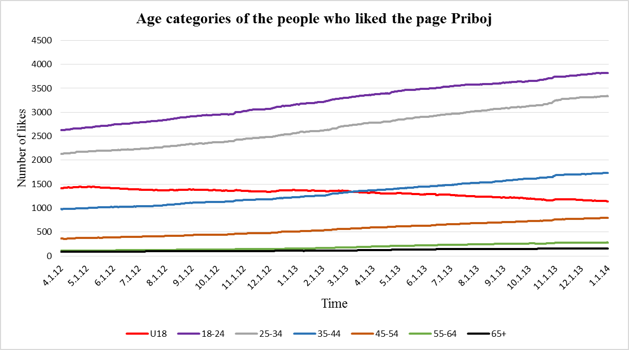

Source: Priboj Facebook page, February 19, 2014.

The stagnating presence of under-18 visitors and growing trend of the mid-age followers can be explained by seriousness and importance of the topics mentioned on the page. The page increasingly addresses the issues which are more related to the concerns of adults than minors. Disregarding those older than 55, who are not likely to use internet, the trend on the graph shows that the population with the voting rights (over 18) turns to Facebook page “Priboj” to get the information and voice their concerns.

- Right to inform and to be informed

Considering that a great number of people started following the page, administrators used the opportunity to inform, ask for information sharing, warn on danger and call followers for discussions about the local issues. Topics addressed on the page included information about the work of the local government, public services, local sports, cultural events, crisis situations etc.

After the local parliament voted on the permission for building small hydropower plants on Lim river, which are strongly opposed by the majority of the locals, Facebook page “Priboj” published the list of names of the representatives in the the local parliament who voted “yes.” In addition, it suggested broadcasted round-table discussions about the hydropower plants. With the information provided local residents got the opportunity to hold their representatives accountable for affirmative voting and ask them to explain their choice in this case.
On the other occasion when the local workers were deceived by the contractor and left in Sweden, page “Priboj” provided valuable information to their relatives:

Mayor Lazar Rvovic informed us that the Municipality is ready and willing to help our citizens who are left in Sweden but that cannot be done based on writings on Facebook. Thus, via our page, he invites the parents and families of the people who departed to Sweden to come tomorrow at eight o’clock to the Municipality building, and together find out the best way on how to return them [the workers] to Priboj. Admin team of Priboj.

Page “Priboj” also called locals to voice their concerns and share any information they believe others should know. It showed to be useful in warning local residents about the dangers and quickly spreading the information about the issues. For instance, “Old part of Priboj has no water! The pipe broke again … Police is regulating the traffic, underpass is flooded.” Recently, the discussion emerged after the admin team asked followers for their opinion on the new electricity bills which were unusually high. The discussion calmed just after one of the visitors posted excerpt from the consumer protection manual and suggested the proper way to address the issue. In short, the page provided a new forum for information sharing, exchange of opinions and discussion. It gave an opportunity to the inhabitants of Priboj to express themselves and be noticed by others, regardless of their social and economic status, education, religion or ethnicity.

- Action

As the “Priboj” page grew, it became not just the platform for information sharing and public discussion, but also powerful tool of mobilization. In lethargic ambience of Priboj with average inhabitant age well above 40, it was hard to imagine any mobilization possible. Yet, the administrators of the page took their chances. During the recent national online challenge organized by “CocaCola Hellenic”, “Priboj” page started inviting citizens to participate and vote for Priboj to get the open public gym. At one point they even invited all owners of local businesses to provide free WiFi so the citizens could vote. Surprisingly, Priboj won the challenge competing with forty other Serbian cities. Yet, due to bureaucratic problems and alleged negligence of the local officials, the gym was never installed. The recent comments on the page started calling for accountability of the local government.

Just four months later, the workers of FAP dissatisfied with their working conditions and possible closure of the factory, decided to start the mass protest and block the international railway. In just a few days people started organizing groups of support and sharing them via “Priboj” page. The protest escalated and persisted until the Deputy Prime Minister visited protesters and offered them restructuring program. The similar situation emerged after the municipal fuel-based heating system failed in middle of the winter, causing mass protests. The admin team did not take active role in organizing the protests, but allowed the outsider posts on the page to act as a mobilization tool.

The practice to call or allow others to call for action via page for some publically beneficial cause persisted ever since. Calls for financial aid, humanitarian events, blood drives, public discussions and cultural events became common.

- A Call For Accountability

In October 2011 “Priboj” started initiative “I don’t want Priboj like this.” The initiative took a form of the Facebook album left to citizens to fill it in with the pictures of neglected infrastructure and parks, stray dogs, law violations, and similar problems of public interest. Soon, the album was replete with pictures from all over the town, stressing on problems that should be solved. The post following one of the photos reads:

This is one of the ways to influence institutions in charge! Hence, we invite inhabitants of Priboj to submit their photos witnessing recklessness and negligence of individuals and institutions, all in attempt to push for action and make our town look better.

Playground for children in the old part of the town has been ruined during the winter due to harsh conditions and vandalism. For more than three months, broken installations, crashed toys and dirt have been on the playground without reaction of any agency or the local institution. Just after the pictures of devastated playground went viral on the Priboj page and caught the wider public attention, the local institutions acted and cleaned it up.

There was a number of similar stories with the uncharted dumps, unregulated parking lots, damaged public property, dirt roads and inefficient public service. One of the most well-known was the Facebook post in form of appeal to fire brigade to locate and fight the wildfire in a neighborhood. Just minutes after the post, the fire brigade acted upon.

The local government ended up being not the only target of the Priboj’s initiative that is still alive. After one of teachers posted the picture of bad conditions in her classroom, the local school acted quickly and provided funding for reconstruction. As some of the problems were solved, the citizens became more active in posting the new pictures and calling the institutions to solve problems. Not all presented problems are solved or addressed appropriately. Yet, the awareness of those problems and the public pressure to solve them increased.

- Government Enters The Online World

In July 2012, just after the election, the new President of the City Parliament S.V. created the professional profile on Facebook calling citizens to ask questions, address problems, and give suggestion through it. Short after, he initiated rebuilding of the official website of the town, including the “48 hours system” which was designed to collect or report issues and forward them to the offices which should address them. The system was relatively successful, while his official Facebook page, electronic service, website and more prompt responses were seen as the positive development.

Previously working as a professor with the degree in Telecommunications and Electronics, S.V. claims to have understanding of importance of communication and advanced technology. Therefore, he sees “Priboj” page as a positive contribution to the public discussion and democratic development.

Citizens want to be heard when they point to the problem. Page can succeed only if the public officials, institutions and local government see the problem indicated by people, and respond to it. The page can be successful only if it is apolitical and deals with real arguments and provides truthful news, not the media speculation. Citizens express their opinion on the page which should stimulate it further by providing fair news. I'm not sure that it has been that way, but the Priboj page is good and it serves for active involvement of citizens in solving problems in our local government.

Commenting on the effects of the “Priboj” page’s initiative and overall purpose, he says that the officials do react to the extent they are IT literate and ready to use social networks and actively respond to raised issues.

- To Be Continued…

By visiting Priboj, one will still sense political apathy, feel lethargy in the air and maybe meet few older citizens with grim faces. Contrary to this, one click to “Priboj” will uncover the world of public discussion, suggested cultural events, fresh news and bright initiatives. As the parliamentary elections in Serbia are coming soon, the admin team of “Priboj” has a challenge to allow and stimulate public discussion, but at the same time to remain politically neutral.

CASE STUDY ANALYSIS

The central issue of this case study is the way one unofficial Facebook page influences public sphere communication and discussion in lethargic and politically passive community. The case study also addresses the ability of the same Facebook page to remain neutral while serving as a tool of citizens’ mobilization. Over the past few years of the active online life of the small municipality presented in this case study, not all the problems were solved. Yet they became visible, calling for accountability of the institutions or individuals in charge of solving them

CASE STUDY QUESTIONS

- How did the “Priboj” page influence the public sphere communication in this small town?

- What is the role of the “Priboj” page in mobilization of citizens?

- Why citizens kept posting the pictures and remarks on different problems on the “wall” of the “Priboj” page?

- Assuming the same situation, would the “Priboj” page have the same success in addressing citizen’s issues if there was no S.V. or the other IT literate official in the local government? Why?

- Will the “Priboj” page eventually become redundant and unnecessary considering the increase of the official online and offline communication channels in Priboj? Why?

References

2011 Census of Population, Households and Dwellings in the Republic of Serbia; Age and Sex Data by Settlements (Belgrade: Statistical Office of the Republic of Serbia, 2012), 150.

Census of the Population, Households and Dwellings in 2002; Population (Belgrade: Statistical Office of the Republic of Serbia, 2004), 92.

Priboj Facebook Page, accessed February 19, 2014, https://www.facebook.com/priboj

1. Census of the Population, Households and Dwellings in 2002; Population (Belgrade: Statistical Office of the Republic of Serbia, 2004), 92.
2. 2011 Census of Population, Households and Dwellings in the Republic of Serbia; Age and Sex Data by Settlements (Belgrade: Statistical Office of the Republic of Serbia, 2012), 150.
3. Priboj Facebook Page, accessed February 19, 2014, https://www.facebook.com/priboj
4. Names of the admin team members are known to the authors. Stated age is as of February 2014.
5. Ibid.
6. Ibid.
7. Ibid.
8. 2011 Census of Population, Statistical Office, 150.
9. Priboj Facebook Page, February 19, 2014.
10. Ibid.
11. Priboj Facebook page, accessed February 19, 2014, https://www.facebook.com/priboj
12. Ibid
13. S.V., e-mail message to the authors, February 18, 2014.

